Would I Lie to You? Web App: Project Plan

Project summary
The Would I Lie to You? web app will be handed over to Graham Fry on Tuesday 17 November 2026, 3 working days after kick-off. Development takes about 4 hours; Graham then tests for 2 days, with fixes made during those 2 days.
Item | Detail
Product | 3v3 browser game based on the TV show, with AI-generated lies
Start | Thursday 12 November 2026
Development | Friday 13 November 2026 (about 4 hours)
Client testing and fixes | Monday 16 to Tuesday 17 November 2026
Handover | Tuesday 17 November 2026, end of day
Running cost | Free: the local AI and the lie bank cost nothing to run

Status at 12 November: requirements, test plan and module design are done, and a working first version passes all 34 automated tests. The code is written with AI assistance, which is why development is measured in hours rather than weeks.
Related documents: WILTY (BRD), WILTY (TEST REQUIREMENTS), WILTY (MODULE BREAKDOWN).

Timeline
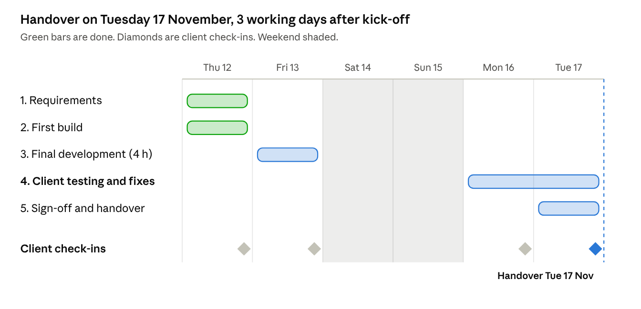
Requirements and the first build are done. Development finishes on Friday, Graham tests on Monday and Tuesday, and handover is at the end of Tuesday.

Phases and deliverables
Phase and dates | Deliverables | Effort
1. Requirements (Thu 12 Nov, done) | BRD, test requirements, module breakdown | Done
2. First build (Thu 12 Nov, done) | Working v1 of the game; 34 automated tests passing | Done
3. Final development (Fri 13 Nov) | White theme; free local AI model option (Ollama); larger lie bank; all 34 internal test cases run and passing; UAT pack for Graham | 4 h
4. Client testing and fixes (Mon 16 to Tue 17 Nov) | Graham plays the UAT scenarios; issues fixed and retested the same day | 2 days
5. Sign-off and handover (Tue 17 Nov, end of day) | Go/no-go, user guide, code and install handed over | 30 min

Out of this plan: fine-tuning our own AI model. It is a good follow-on project but is not needed for the game to work, so it would be agreed as a separate change request after handover.

Roles and responsibilities
Role | Who | Responsible for
Client | Graham Fry | Final say on scope; attends check-ins; runs client testing; signs off
Project manager | Abdul-Haque Mohammed | Plan, daily updates, risks, change requests, running check-ins
Developer | Abdul-Haque Mohammed | Design, AI-assisted coding, internal testing, fixes, handover
Testers (UAT) | Graham Fry plus 5 players he chooses | Playing the UAT scenarios and reporting issues

One person is both project manager and developer, so Graham's single point of contact is Abdul-Haque Mohammed for everything.

Communication and client check-ins
Graham gets an update at the end of every working day of the project, and any decision he needs to make is flagged at the check-in before it is needed.
What | When | How
Daily update | End of each working day | Email, using the template below
Check-in | End of each working day, 15 min | Video call or in person
Urgent issue during testing | Within the hour | Message, then a follow-up email
Change request | When raised | Change request form (see Change control)

Check-in schedule
Date | Check-in | Client decision needed
Thu 12 Nov | Kick-off and requirements review | Approve BRD and test requirements
Fri 13 Nov | Demo and ready-for-testing | Approve the look; choose the default AI option; confirm testers
Mon 16 Nov | Testing day 1 review | Agree which issues to fix on day 2
Tue 17 Nov | Go/no-go and handover | Approve handover and sign off the project

Daily update template
- Overall status: On track / At risk / Off track
- Done today:
- Planned tomorrow:
- Issues found and fixed:
- Decisions needed from Graham:

Client testing (UAT)
Client testing runs Monday 16 to Tuesday 17 November. Graham and 5 players of his choice play real games and check the app does what the BRD promised. Fixes are made during the same 2 days, so testing and fixing overlap rather than running one after the other.

How it works
1. Fri 13 Nov: project manager sends the UAT pack: install or link, this scenario list, the feedback form.
2. Mon 16 Nov, morning: 15-minute walkthrough with Graham, then testing starts.
3. Mon 16 Nov: testers log issues; Critical and Major issues are fixed the same day.
4. Mon 16 Nov, end of day: check-in to review issues and agree what is fixed on day 2.
5. Tue 17 Nov: testers retest the fixes and finish any scenarios left; go/no-go at the end of the day.

Scenarios
ID | Scenario | Passes if
UAT1 | Set up a 3v3 game and enter everyone's stories | No one sees another player's stories
UAT2 | Play a full 6-round Local AI game | Lies feel believable; scores and winner are right
UAT3 | Play a full game with the lie bank | Game works with no AI and no internet
UAT4 | Finish 6 rounds with level scores | Sudden death starts and produces a winner
UAT5 | Guess early with Ready to Guess, and let the timer run out once | Both lead to the guess screen; the beep plays at 0:00
UAT6 | Type a wrong key (e.g. X) as a guess | App asks again; no points change
UAT7 | Play 3 games in a row | No lie repeats
UAT8 | Run a game in test mode | TRUTH or LIE shows on screen; marked as a test game
UAT9 | Play a game with Local AI while Ollama is closed | The game says it couldn't reach the local AI and uses the lie bank

Issue severity
Level | Meaning | Fix by
Critical | Game cannot be finished, scores are wrong, or the guessing team can see the answer | Same day
Major | A feature does not work as the BRD says, but there is a workaround | Before handover
Minor | Wording, layout or look | Agreed at the Tue 17 Nov go/no-go

Feedback form fields
- Tester name and date
- Scenario ID
- What happened, and what you expected
- Screenshot (if possible)
- Severity (tester's view)

Entry and exit
- Starts when: all 34 internal test cases pass, and there are no known Critical issues.
- Ends when: every scenario has passed, no Critical or Major issues are open, and Graham confirms in writing.

Change control
The scope is the signed-off BRD. Anything outside it goes through a change request, so the timeline never slips without Graham agreeing.
1. Graham (or the project manager) describes the change.
2. Project manager replies the same day with the impact: extra time, new dates, risks.
3. Graham approves or rejects in writing.
4. Approved changes are added to the plan and the BRD version number goes up.
Small wording or colour tweaks raised at a check-in do not need a change request.
Change log: CR-01 (free local AI option) raised and approved on Thu 12 Nov. CR-02 (remove Claude) raised on Thu 12 Nov, awaiting approval. Both built within Friday's development time; handover date unchanged.

Sign-off points
Milestone | What Graham signs off | Date
Requirements | BRD and test requirements | Thu 12 Nov
Ready for testing | Look of the app and default AI option | Fri 13 Nov
Handover | UAT results, final product, user guide, code | Tue 17 Nov

Risks
Risk | Likelihood | Plan
2 days is not enough to fix everything testing finds | Medium | Critical issues fixed same day; Minor issues can move to after handover
Graham unavailable on a testing day | Medium | Testing moves back one day; decisions can be confirmed by email
Ollama not installed on the testing laptop | Medium | Game falls back to the lie bank; Ollama install steps are in the UAT pack
Free local model gives poor lies | Medium | Prompt shows the model good example lies; lie bank as backup
AI-written code has hidden bugs | Low | 34 automated tests plus the UAT scenarios
Scope creep (new features mid-build) | Medium | Change control process

Budget
Item | Cost
Development | About 4 hours, plus fixes during testing
AI lies | Free (local model)
Local AI model, lie bank | Free
Hosting (if deployed later) | Free tier on Render or Railway to start

Assumptions
- Graham and his testers are available on Monday 16 and Tuesday 17 November.
- The testing laptop has Ollama installed, or testers use the lie bank.
- Testers have a laptop with Chrome, Safari or Edge.

Note: this project is a simulation of a real client engagement, run as a work experience exercise. Graham Fry acts as the client. All dates, check-ins and sign-offs are illustrative, not real commitments.

